Drawing Contours based on your Field Work

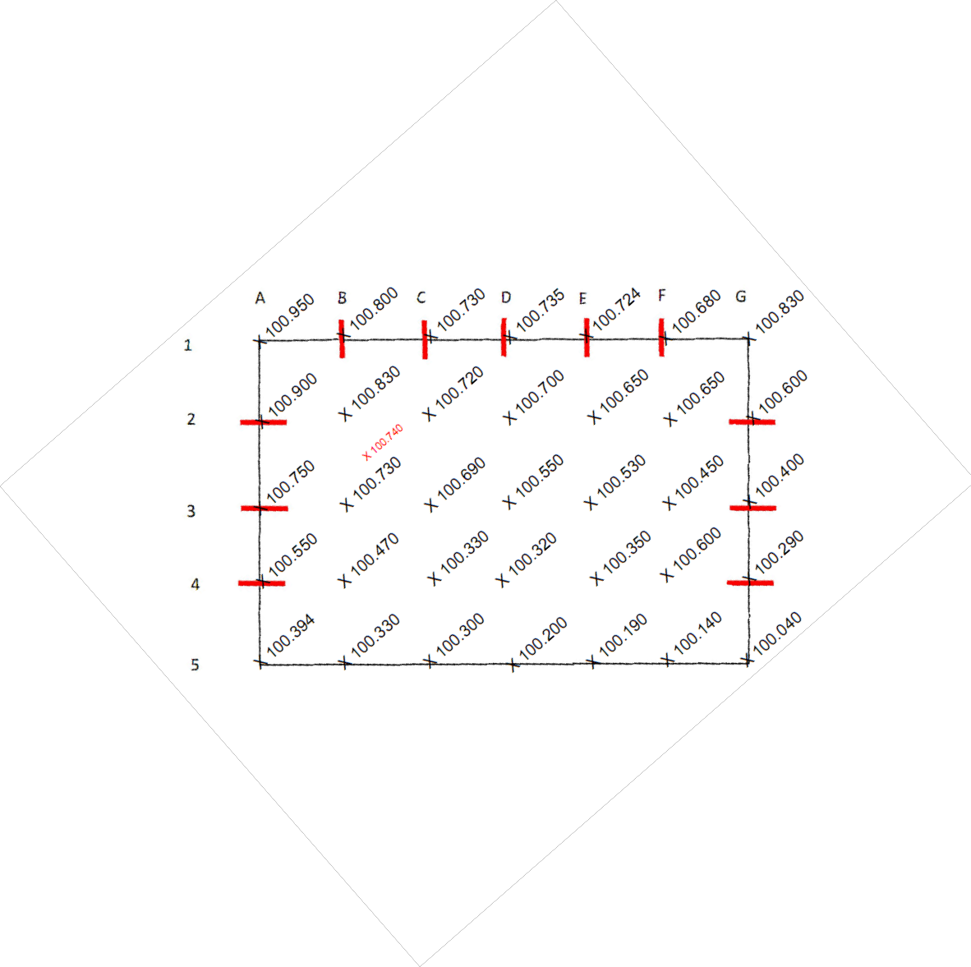

So far you have recorded the data of a piece of land and produced a drawing showing spot heights at regular grid intervals. While this drawing provides some information about the land it requires some interpretation.

A contour drawing is prepared based from the grid drawing with the spot heights you prepared previously. As discussed in the previous chapter a contour drawing allows us to get a quick view of the “Lay of the land”.

The first step is to determine the contour interval. For a step site the contour interval should be large e.g. 500mm. For a flatter site the contour interval should be e.g. 200mm.

In our example the highest part of the site is at grid A1 being RL 100.950. The lowest part of the site is at grid G1 R.L. 100.040. The fall over the site is 910mm. A contour interval of 500mm would be meaningless as there would only be 1 contour line on the drawing. For this task a contour interval of

200mm would be more suitable.

For this drawing we need to plot the following contour lines, I. RL 100.800

II. RL 100.600

III. RL 100.400

IV. RL 100. 200

Plot Contour Line RL 100.800

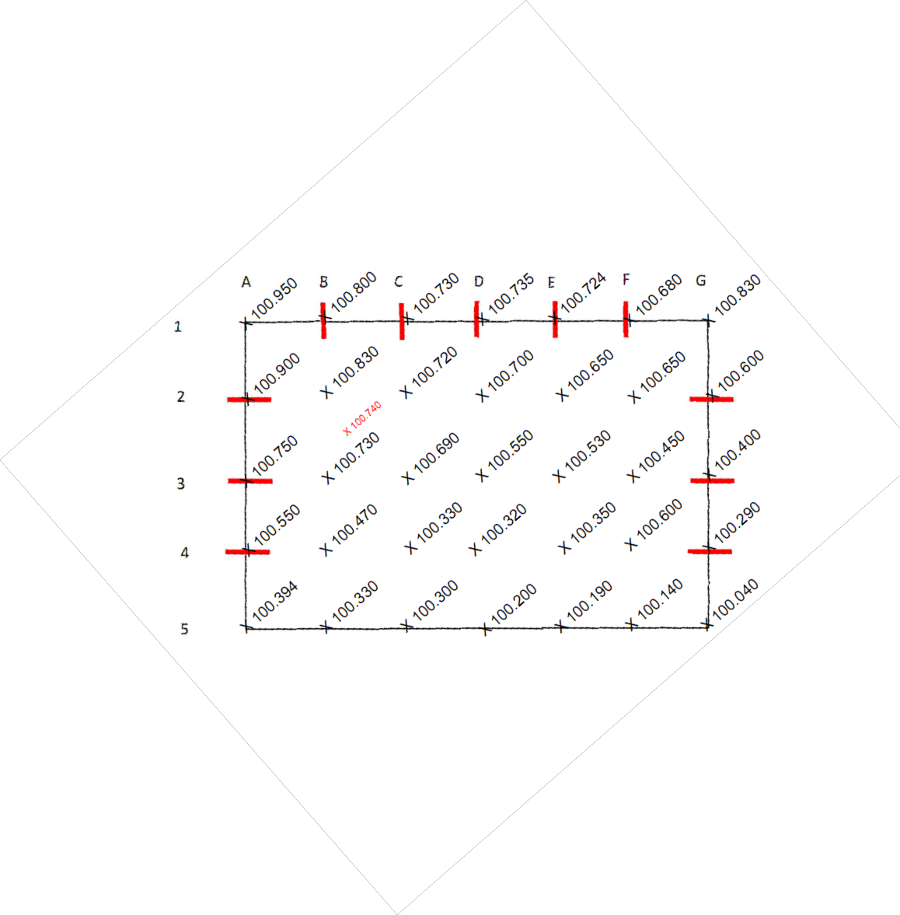

If we recall when we set out the grid they were spaced evenly, so on our scaled drawings the grids should be evenly spaced.

Firstly we need to measure the distance between the grids, we do  **not** need to consider scale. For the drawing in this example the distance is 50mm between the grids.

Firstly we must identify the grids that the 100.800 contour passes through.

Contour passes thru grid point B1

Contour does not

pass thru these grids

Contour passes between grids

B2 & C2

A2 & A3

B2 & B3

Where the contour passes through a grid point it is quite easy to plot the contour line. At grid point B1 the measured reduced level is 100.800. The contour line will pass through this point.

We identified that the contour passes through the grid line between points B2 to C2. To determine where the 100.800 contour line crosses the grid we must interpolate the

intersection point with the following formula,

Distance is measured from highest spot height to contour measured along the grid.

To locate the 100.800 contour on the B2 to C2 grid we use the formula in the following manner.

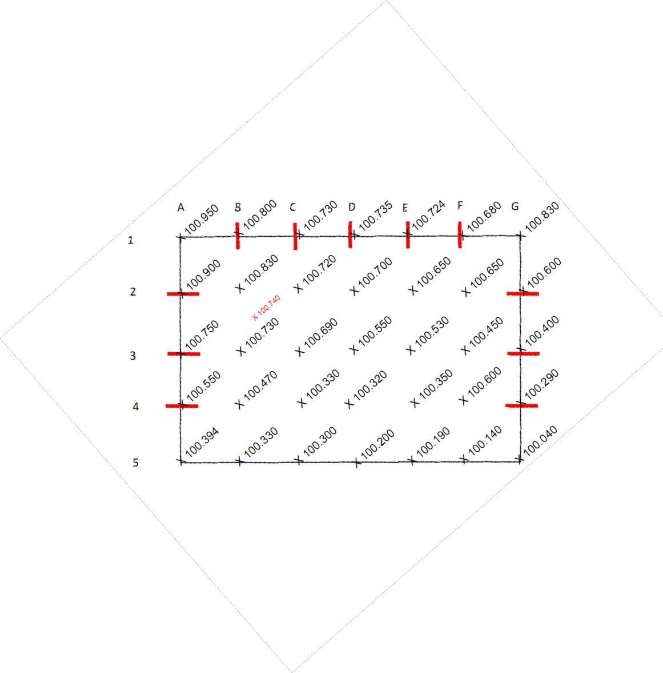

Distance = 14mm to be measured from grid point B2.

Mark position of the contour 14mm from B2 spot height towards C2

We also determined that the contour passes through the grid B2 to B3 so we now interpolate that grid.

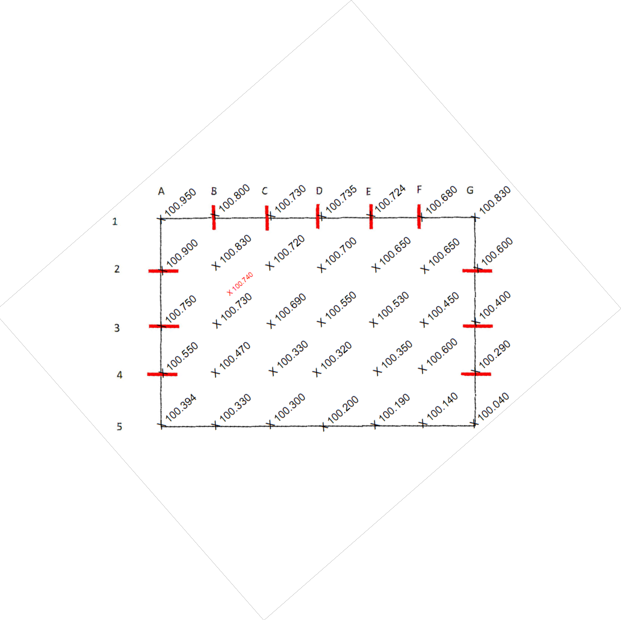

Distance = 15mm

Mark position of the contour 15mm from B2 spot height towards B3

We also determined that the contour passes through the grid A2 to A3 so we now interpolate that grid.



Distance = 33mm

Mark position of the contour 33mm from A2 spot height towards A3

If you are unsure what the contour does across the grid you can do the same process diagonally across the grid. We can interpolate from A2 to B3 across the grid. As it is a diagonal measurement across the grid the width will change. In this case it will increase to



71mm.

Distance = 42mm

Mark position of the contour 42mm from A2 spot height towards B3

We can repeat the process from B2 to C1



Distance = 21mm

Mark position of the contour 21mm from B2 spot height towards C1

You should also interpolate from the grid to items specifically recorded such as trees, services etc. This is important as these items have been identified as items that may affect the design. It will be important to measure the ground at this point. You will also need to



alter the grid distance.

Distance = 6mm

Mark position of the

contour 42mm from A2 spot height towards B3

Once you completed interpolating all the relevant grids you are ready to draw in the contour. It is simply a matter of joining the dots keeping in mind some rules in relationship to contour lines.

1. **Contour Lines Never Cross each other** – Ultimately a point can only have one height.

If contours cross each other it would mean it would have two heights above the datum which is physically impossible (Remember Contours indicate a height above the datum).

Contours at a vertical cliff face will sit on top of each other but each point of the cliff face is a different piece of the land.

2. **Contour Lines Never End** – Ground will always meander up and down towards creeks, rivers & sea level. Where the ground falls away a hill is formed and the contour will join back on itself in a circular fashion.

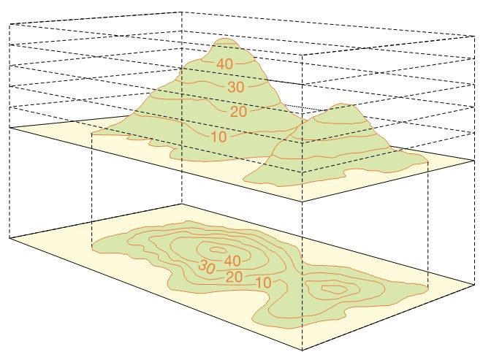

3. **Contour Lines never split** – Contours indicate the  **transition** of the ground level passing through contour interval.

A contour may appear to split, but remember a ridge is formed by 2 sides of a hill coming together so in fact there are 2 contour lines.

When joining the contour points you should curve the lines where appropriate instead of just using straight lines as in nature it is very rare that straight lines are formed.

If lines are not rounded it still gives a good representati on but it is

not realistic.

100.800

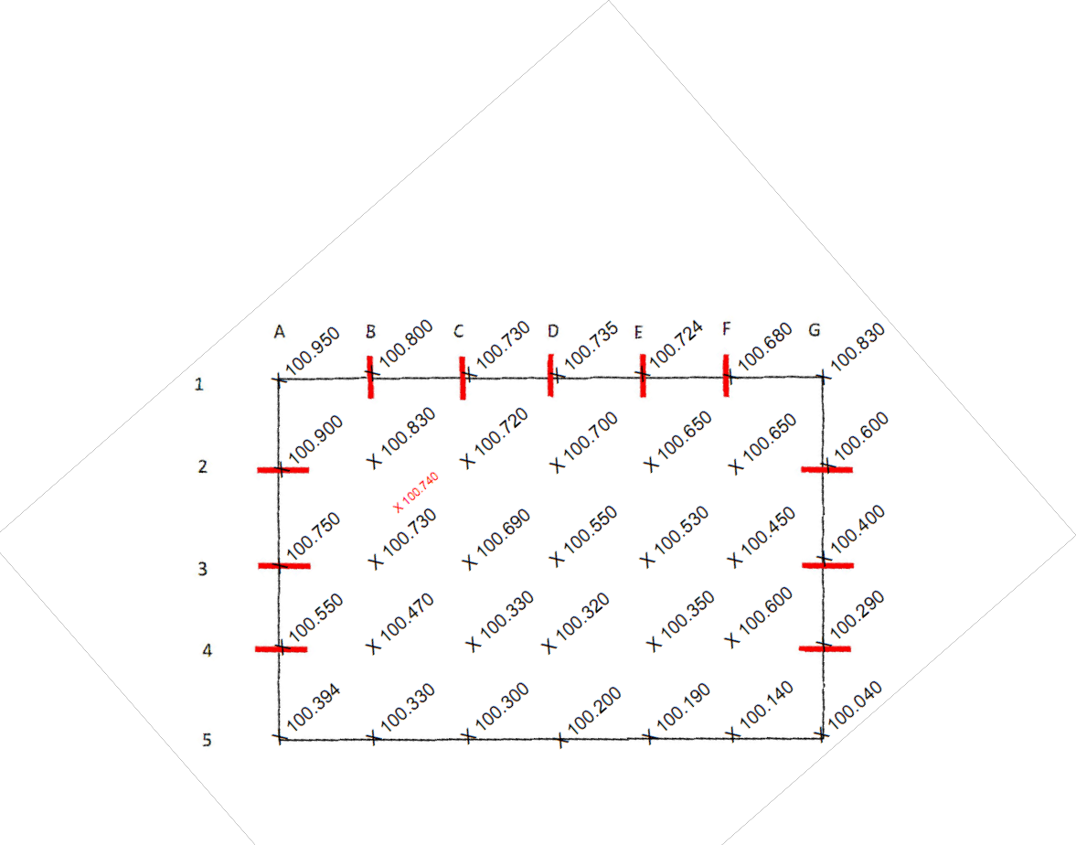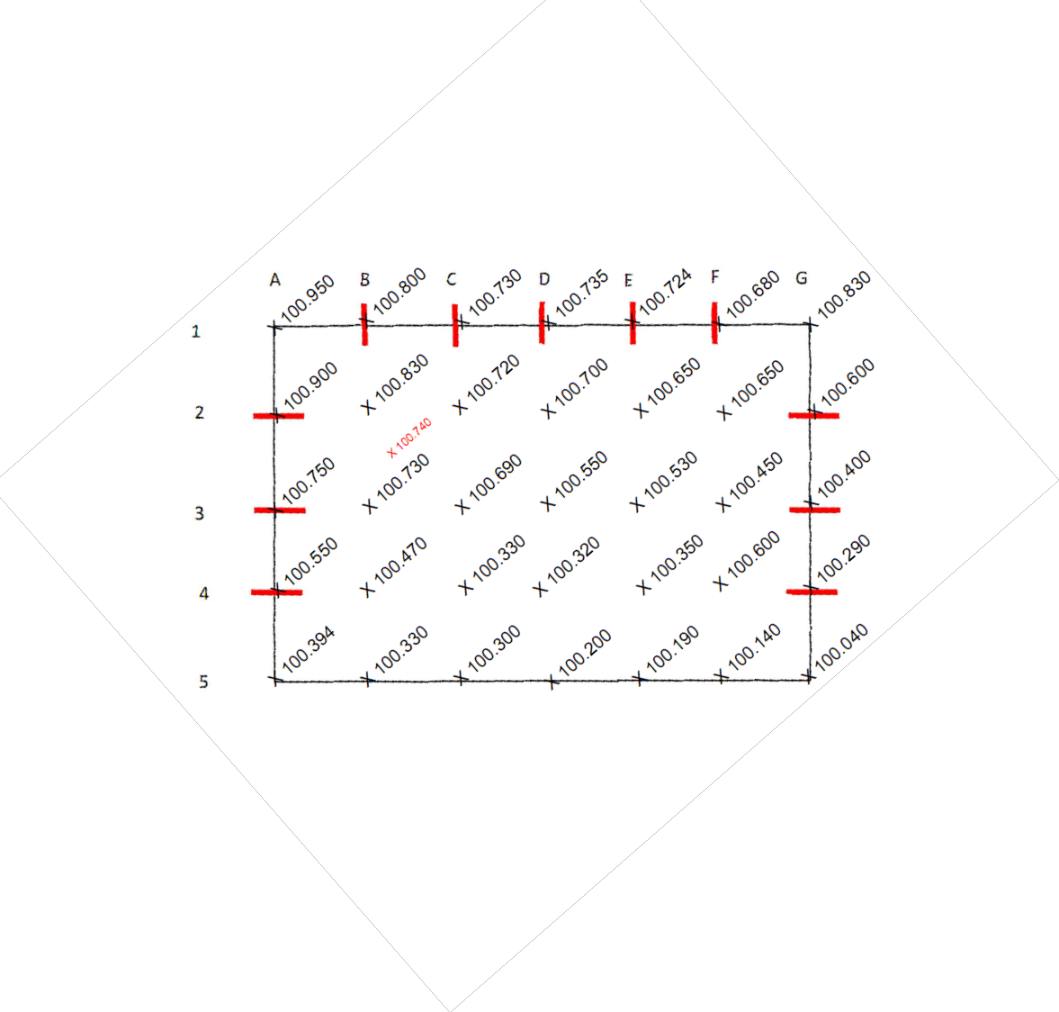

Compare against using rounded lines

Lines are smoothed to give a more

realistic fit

100.800

10

Interpolate and complete the rest of the contours.

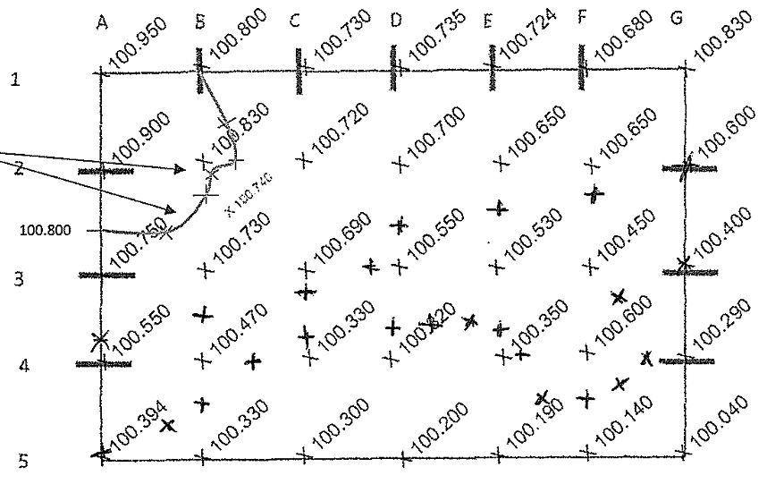

100.600

100.200

100.400

Normal a site plan will not display spot heights (some may displayed for critical points).

Usually a Site Plan will show contours & significant features.

100.800

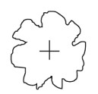

100.600

100.200

100.400

**Drawing a grid drawing from a contour drawing**

In the last section we looked at the situation we look at drawing a contour drawing from your grid observations. As highlighted it is a useful tool to allow you to conduct feasibility studies.

As builders you may do this a few times but it is more likely you regular encounter with contour lines will be when you are given drawings to price.

You are likely to be given a site plan to price a project. Contours on the plan will indicate the heights of the land. From this you will determine the cut and fill requirements and form a price accordingly.

There are 2 methods to determine volumes in relation to earth works,

1. Grid method and sum of squares and

2. Longitude & Cross sections and Simpson’s rule.

In this section will be looking at the grid method. The Grid Method

This method is simply a reverse of what we did in the lesson above. From the contour drawing we recreate the grid.

Step 1

On our contoured drawing were place an even grid. Grid size is  **IMPORTANT**. You must use a scale ruler and select a dimension that is,

1. **Relevant**- A grid size of 100 metres will be too large and no reliable quantities will be determined later.

2. **Ease** – Select a grid size that will make your later calculations easier when you need to do the volume calculations e.g. uses a grid size of say 10m x 10m instead of 13m x 13m

Draw the grid as described and this time lightly draw in the grid lines.

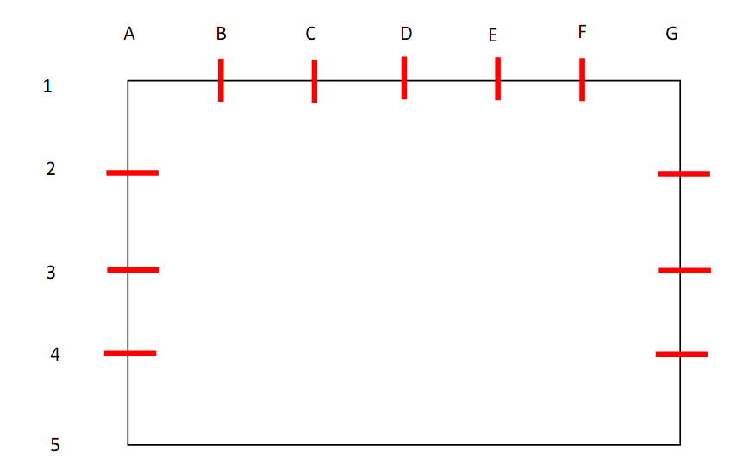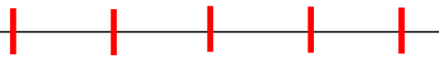

100.800

100.600

100.200

100.400

Step 2

Identify grid intersections that the contour lines pass through.

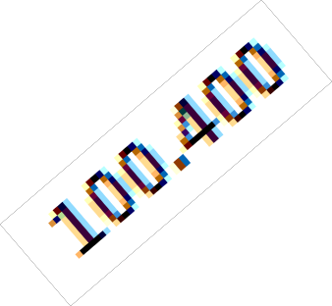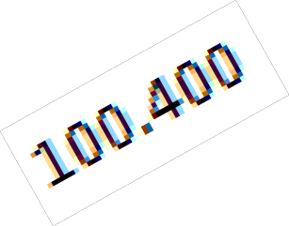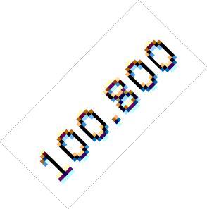

100.800

100.600

100.200

Step 3

Using the following formula interpolate the grid spot heights.

r Contour) x (Distance from Higher Contour to Grid ÷ Distance Between Contours